

**MEMORANDUM OF UNDERSTANDING**

This is a document validating an agreement between **MR. OGABOR JOHN AND MRS. OLUBUKUNOLA OLAYIMIKA AJAYI** for the collaborative of 20% interest over a sum of **TWO MILLION, FIVE HUNDRED THOUSAND NAIRA ONLY (N2,500,000) paid on the 15th of May, 2020.**

There is a binding agreement to pay the initial capital invested, alongside the interest, **THREE MILLION NAIRA ONLY (N3,000,000) on the 15th of June, 2020** by **MR. OGABOR JOHN TO MRS. OLUBUKUNOLA OLAYIMIKA AJAYI.**

Attached with this document is an evidence of payment by **MRS. OLUBUKUNOLA OLAYIMIKA AJAYI.**

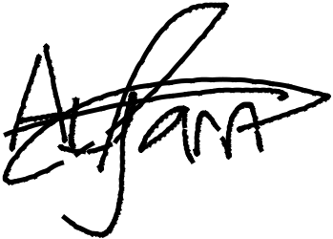

_________________________

_~~__~~_____~~___~~_~~_~~___________



**MRS. OLUBUKUNOLA OLAYIMIKA AJAYI**

**MR. OGABOR JOHN**

***(CEO, JOHN INVESTMENTS)***